The Woodworm

|  |  |  |
| --- | --- | --- |
|  | **July 2020** |  |

Newsletter of Manning-Great Lakes Woodworkers Inc.



# Opinions expressed are not necessarily those of the Editor or Management Committee of the

# Manning-Great Lakes Woodworkers Inc.

***If you need to change a roster date let Kim know, this roster is consistent with the whiteboard in the club***

**Some important dates for your calendar**

**General Club Duty Roster**

**Privately respect social**

**Distances and personal**

**Hygiene**



**Committee**

**Meeting on the second Friday**

**At 9.30am**

**Please make sure you read the minutes of the meeting when you get them.**

***Please make sure you read the minutes of the meeting when you get them***

**\*New tools have been purchased and hung behind the workbench, as a shadow board has been made please return when finished.**

**Members must remember to clean up after themselves when using the machinery, especially the new Linisher.**

**\* Gallery - rostering details in Woodworm, and on calender in the club.**

**\* Workshop duty roster - to look after new members.**

**\* Gallery and external Club activities - wear club shirts or name tags.**

**\* Club name badge requests to Kim, club shirts & jackets see WorkWise, in Whitbread St Taree..**

**Saturdays are being well attended, don’t forget to bring in food to use on the BBQ.**

**Remember the Saturday after the Committee meeting will be a club sponsored Sausage sizzle, so come along and bring your project and appetite, just giving a bit back to the members.**

Workshops that were planned for this year, If they are to go ahead you will be informed.

**Duty Roster is on the Whiteboard, as no-one has offered to put their names up, Kim will nominate for you.**

**New Hours of Workshop operation**

Open every Saturday 9.00am to 3.00pm

2nd Friday 9.00am to 3.00pm

3rd and 4th Tuesdays 9.00am to 3.00pm

1st and 2nd Tuesdays if desired arrange with Bernie.

**Committee meeting**

2nd Friday 9.30am to 10.30am

**General meeting and Show and Tell Saturday following the Committee Meeting**

Saturday following the Committee meeting there will be a Club Sponsored Barbecue.

Bunnings Barbecues have once again been suspended, the club was to have had Saturday the 2nd August’s BBQ and Bunnings informed us last Monday.

Due to the potential loss of profits that would have gone to the club at these BBQs, Bunnings gave us $500 in gift cards.

A generous offer indeed, but it still doesn’t put money in the bank.

A suggestion was put forward by one of the committee, that perhaps if any member has the need to purchase anything from Bunnings, that they use one of the gift cards and reimburse the club.

That way the coffers get money indirectly put in to assist the club.

This will be discussed at our next committee meeting and any decision of how the gift cards are managed will be made then, and you the members will be informed.

**Show and Tell**

New member Phil

Laminated plywood dolphin

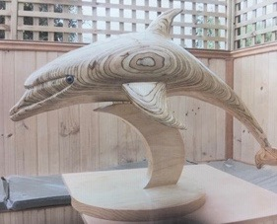 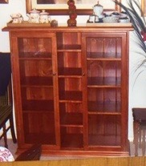

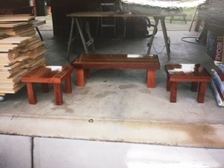

New member Bill

Cutting board, chevron design

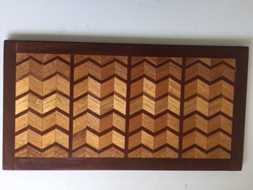

Bernie’s Scania Car Carrier 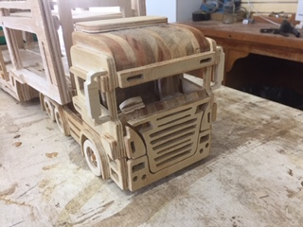

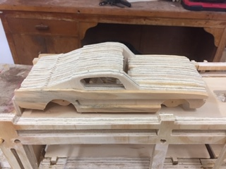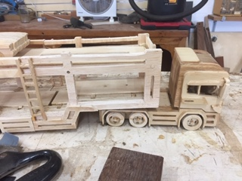 1966 Mustang Fastback

Geoff Ayling changed Show and Tell into a Board meeting

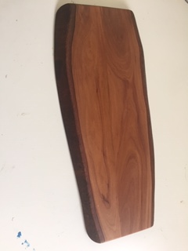 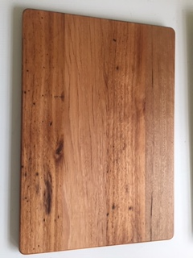

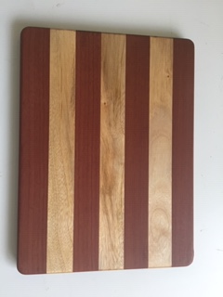 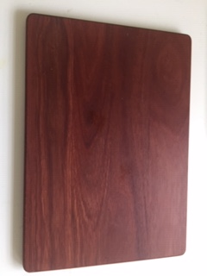

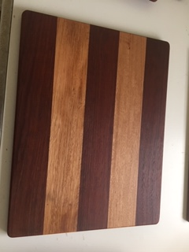 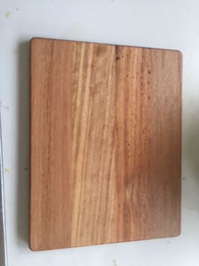

Ben’s Intarsia

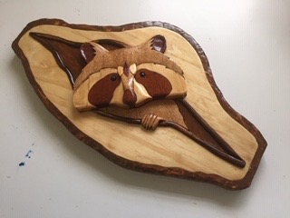

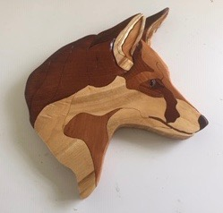

Kim Fetherston Editor